Handling Other Contingencies (Non- IOC, ISO, ISB)

Overview

Current processing
If Manual Quote present in the Book, incoming Tradable cannot trade and gets routed to PAR (see old BOB requirement document for detail).

New requirement
The requirement below applies to handling of Customer and Non-Customer (except IOC, ISO, & ISB contingencies) New BOB/SPX Linkage functionality.
- For incoming Customer Order that doesn’t have IOC/ISO contingency and tradable with CBOE then --
  - If CBOE NBBO, will start the SAL first and after auction ends will trade or book based on quantity and price point.
  - If CBOE not NBBO, will start HAL first and after auction ends will link away (subject to market conditions).
- For incoming non-Customer Order that doesn’t have IOC/ISO contingency and tradable with CBOE then --
  - Route this Order to Firm Correspondent Class PAR.

Assumption
- Trading Class will be enabled for New BOB (SPX Linkage) functionality.
- New HAL will be “ON”.
- Order can be auto linked to Away Exchange (if at better price).
For detail please refer to Requirement document.

Implementation
Handling of Customer Order Logic
- If incoming Customer Order does not improves the same side market (and not tradable) and no auction going on then simple book the Order.
- If auction going on then handle the incoming with auction accordingly.
- If no auction going and CBOE is NBBO then start SAL auction based on rules.
- If no auction going and CBOE is not NBBO the start HAL auction based on rules.

Handling of Non-Customer Order Logic
- If incoming non-Customer Order does not improves the same side market (and not tradable) and no auction going on then simple book the Order.
- If auction going on then handle the incoming with auction accordingly.
- If no auction going and CBOE is NBBO then route the Order to Firm Class PAR.
- If no auction going and CBOE is not NBBO then route the Order to Firm Class PAR.

The new classes are listed below that will be implemented for this functionality; BrokerStrategyFactory will be modified to find these newly implemented Strategy classes:
- BrokerNewBOBCustomerOrderStrategy – Used to handle all incoming Customer-Like Orders for New BOB class except the ISO/ISB/IOC contingencies.
- BrokerNewBOBNonCustomerOrderStrategy – Used to handle all incoming Non-Customer-Like Orders for New BOB class except the ISO/ISB/IOC contingencies.

Main Flow
- All Order for New BOB Class/SPX Linkage will be accepted through acceptOrder() of OrderRoutingDestinationImpl.
- The Order will propagate through and follow common path of BrokerServiceImpl and BrokerImpl.
- After that, Product state check will be done and for appropriate product states (i.e. OPEN and FAST) will proceed to grab the Class/Product level lock.
- After the lock, the request will invoke AcceptOrderCommand that in turns will call processOrder(Order anOrder) on BrokerProcessorHybrid2Impl.
- This will find the right Strategy to process the Order.
- If the Order is treat like Customer then:
  - BrokerNewBOBCustomerOrderStrategy will be retuned to process the request.
  - This strategy will first check to see if this Order is not tradable, does not improves market and no auction going on then book the Order.
  - Otherwise if auction going on then this will call handleAuctionWithIncomingTradable method on appropriate AuctionProcessor.
  - If CBOE is NBBO then, it will call processSALAuction to start SAL auction.
  - If CBOE not NBBO then, it will call processHALAuction to start HAL auction.
  - At the end it will trade or book the Order if any quantity remaining.
- If the Order is non-Customer then:
  - BrokerNewBOBNonCustomerOrderStrategy will be retuned to process the request.
  - This strategy will first check to see if this Order is not tradable, does not improves market and no auction going on then book the Order.
  - Otherwise if auction going on then this will call handleAuctionWithIncomingTradable method on appropriate AuctionProcessor.
  - Whether CBOE is NBBO or not if the Order is tradable to CBOE then route this Order to PAR using returnHybridOrder method on BrokerLimitOrderStrategy.

Scripts
- None

Database
- None

SetContext

XML/DTD

Homes/Services
- BrokerNewBOBCustomerOrderStrategy
- BrokerNewBOBNonCustomerOrderStrategy

ImplPlan

- Sequence Diagram (Customer Order)
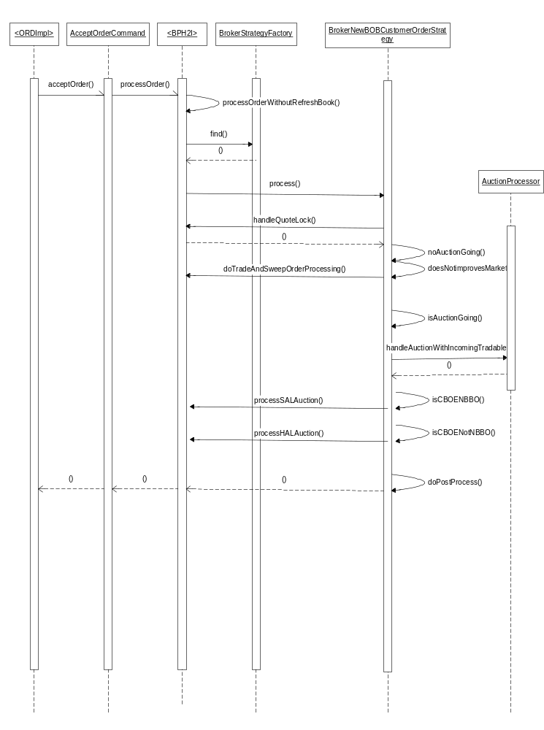

- Sequence Diagram (Non-Customer Order)
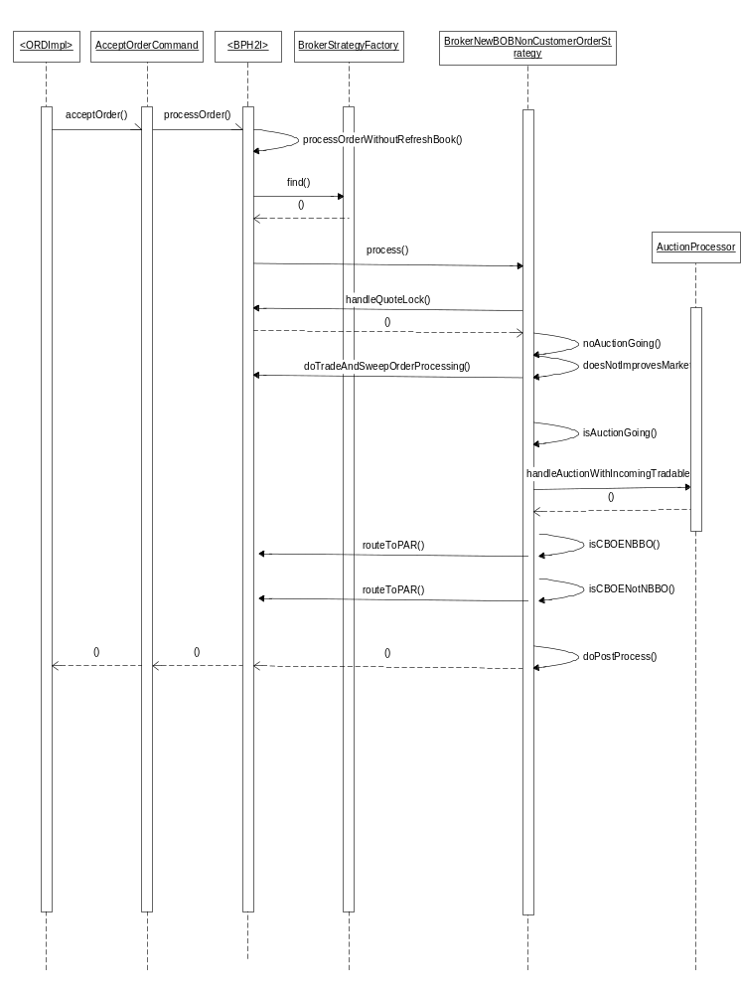

PerformanceTestingProcedure
- .

TestingProcedure

OperatorProcedure
- .

Fallback/Failover

